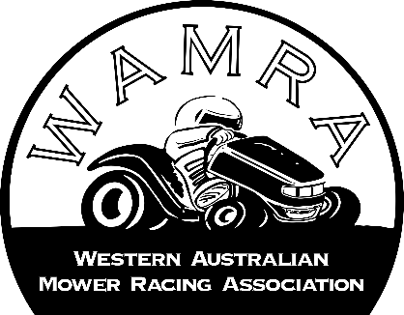
2024 SEASON MEMBERSHIP FORM
Membership type: Please tick below.
$150 Annually | $100 Annually | $50 Annually
Season Race Adult rider,  A season Adult Rider membership form is those whom race in any WAMRA events, to have voice in our General/annual meeting to be involved in out decisions that happen within club. With day fees restricted at $30 per race event SAVING $20 per race event.  OFFER Try 3 full paid events if you wish to become a member receive 15% off our membership | Season Junior Rider  A season junior Rider membership form is those whom race in any WAMRA events under the supervision of an legal adult or guardian must be under the age of 16 years old. With day fees restricted at $30 per race event SAVING $20 per race event.  OFFER Try 3 full paid events if you wish to become a member receive 15% off our membership | Season Social Non racer  A social Non racer membership is to those whom have under age children/guardian, Volunteers and Public whom wish to have a voice in our General/annual meeting to be involved in our decisions that happen within club.
Payment
All memberships payment are required upon signing this form, payment can be made VIA bank deposit, Cash or EFTPOS please see the treasurer of WAMRA for more information
Payment Date:______/______/_________ Signed:__________________(payeer) Signed:_______________ (Treasurer)
The following information MUST BE PROVIEDED below:
I ____________________________________ of _________________________________________Phone:_________________________ Email: __________________________D.O.B:__________________________ Ambulance Membership #: _________________________
Wish to become a Member/Renew my membership for the Western Australia Mower Racing Association. In the event of my admission as a member, i agree to be bound by the rules of the association for the time being enforced.
- I have read understand and agree to the rules and regulations of WAMRA.
- I accept that if I breach the rules, disciplinary action may be taken and membership may be suspended or cancelled, Physical would result in immediate suspension.
Mower Race Class
Junior class (under 16 years old are restricted Maximum capacity of 110CC motorcycle engine. Maximum of 16hp single cylinder vertical drive | Standard/standard modified | C Class Motor size up to 200cc 4 stroke or 125cc 2 stroke.
B Class Motor size between 201 ‐ 250cc 4 stroke or 126cc ‐ 150cc 2 stroke | A Class Motor size between 251cc ‐ 450cc 4 stroke or 151cc ‐ 300cc 2 stroke. | Outlaw Class Motor size greater than 450cc 4 stroke or 300cc 2 stroke
Engine Size: _____________________ Mower brand: ____________________ Race number: _________________
Please Note: Race number is accepted by availability within WAMRA.
Signature of applicant _____________________________ Date: __________/________/_______

